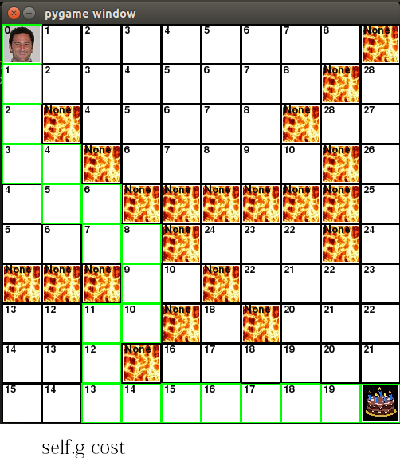

G is how far away the current square is from the original start location. G’s cost is a measure of how much effort (how many moves) it takes to get to a certain square from the start location. This is why the lava tiles have a G cost of “None”: Since they are not walkable tiles, they cannot have a G. This is also why the white tiles surrounded by lava in the top right corner have a cost of 28- To reach these tiles, Paul must detour around all of the lava, which is very far and thus very costly.

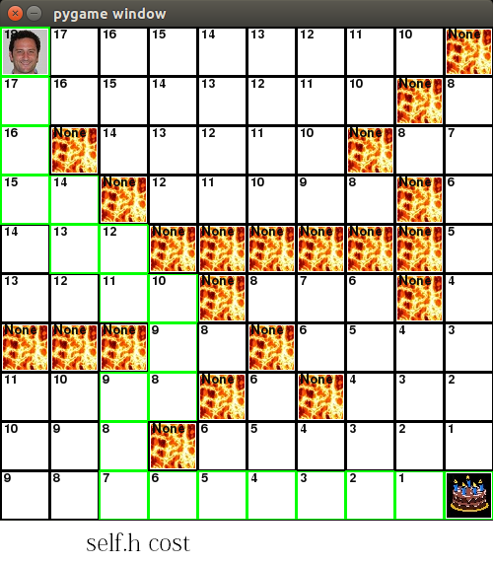

H is kind of like the opposite of G- H is a measure of how close your square is to the goal square, with 0 being the goal square. H does not take lava into account when calculating, which is why squares on the top right corner can have H costs of 10 on one side of the lava, and 8 on the other side, instead of having two really different H costs. (The square that should have had an H cost of 9 *is* the lava, but lava doesn’t have H.) This is also why the H cost of the green optimal path temporarily increases from 8 back up to 9- To reach the final goal, you actually need to move farther away first. This is counterintuitive and costs more, but ultimately succeeds.

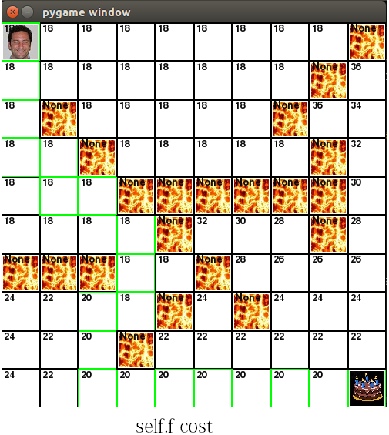

F is a measure of the projected total cost for taking a certain route. You find F by taking the sum of G and H- how much you had to move, and how far you have left to go. So long as you’re moving closer to the cake, this cost will stay constant at 18. (H and G increase and decrease at the same rate, thus cancelling each other’s effects out.)

However, note what happens when you must move farther away from your goal- F suddenly increases to 20. This is because you must still exert energy to move (G cost), but you’re not getting any closer to your goal. (H cost.) This increases the estimated final cost.

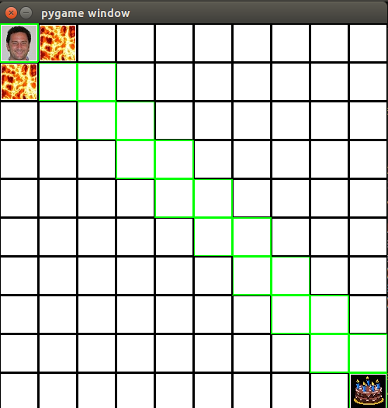

Diagonal motion: Diagonal motion, while costly, is the only way for Paul to escape the lava trap. However, once he has escaped, Paul will only move in the four cardinal directions. This is because moving diagonally costs “3,” while covering the same distance by moving at right angles through two boxes (at cost “1” for each) only costs “2.”

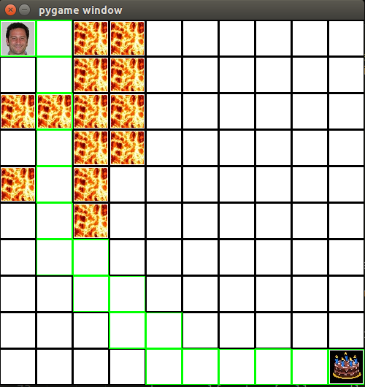

Lava Hopping: Lava hopping, while costly, is the only way for Paul to escape the lava trap. Once Paul has escaped, however, it’s much more cost-effective for him to go around the lava.

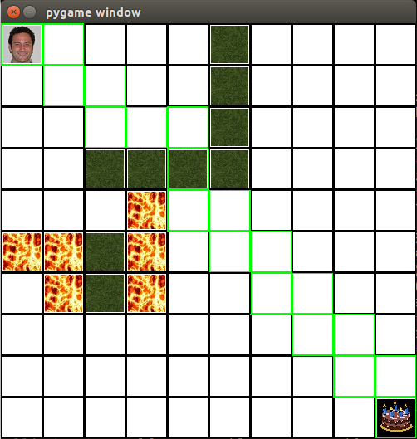

Swampy Paul: